**Project Design Phase-II**

**Technology Stack (Architecture & Stack)**

|  |  |
| --- | --- |
| Date | 16 October 2022 |
| Team ID | PNT2022TMID35428 |
| Project Name | Project - Industry specific intelligent fire management system |
| Maximum Marks | 4 Marks |

**Technical Architecture:**

The Deliverable shall include the architectural diagram as below and the information.

Technical Architecture (TA) is **a form of IT architecture that is used to design computer systems**. It involves the development of a technical blueprint with regard to the arrangement, interaction, and interdependence of all elements so that system-relevant requirements are met.

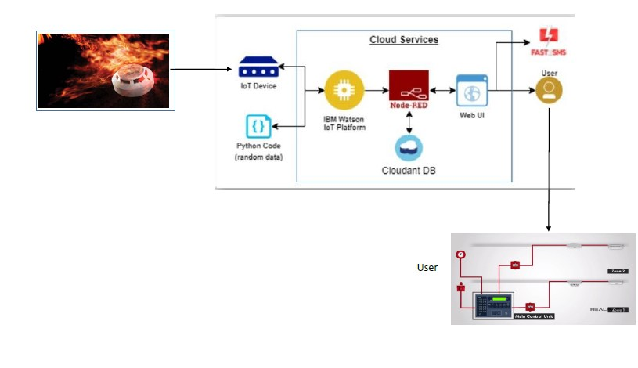

**Table-1 : Components & Technologies:**

|  |  |  |  |
| --- | --- | --- | --- |
| **S.No** | **Component** | **Description** | **Technology** |
|  | User Interface | Sending Alert SMS to user | GSM Module , Wifi Module, Voice Module. |
|  | Application Logic-1 | Gets alert notification through website | Python |
|  | Application Logic-2 | Logic for a process in the application | IBM Watson STT service |
|  | Application Logic-3 | Logic for a process in the application | IBM Watson Assistant |

**Table-2: Application Characteristics:**

| **S.No** | **Characteristics** | **Description** | **Technology** |
| --- | --- | --- | --- |
|  | Security Implementations | Gets notified only by the phone number | Using GSM Module |
|  | Accuracy | More Accurate | Various Sensors |
|  | Performance | High Performance | IOT |